Web Development Assignment Design Docs V1

Issues so far regarding milestone:

As a returning student, I have been re-using my backend code from before. However, because of this, my website will not run properly at present due to issues accessing Chester’s network which occurs both in college and at home, because changes have been made to the sql server access which means that when attempting to load from the database and connect to the server, the website crashes. As such, despite having a fully functioning back end including login pages, checkout pages, registration, admin pages for adjusting menu items etc, my page will currently refuse to run. This is due to chester changing the MFA required to connect, and am currently having this reset through LIS as I cannot authenticate as it is tied to an old phone. I will be creating a new project from scratch until this is resolved, and only use this for layout testing, and will then merge the two.

  - Layout

The plan is to use the bootstrap Album layout for the main categories, as my restaurant of choice would be a chippy. This would not have a lot of categories, and as such the album layout allows using larger eye-catching pictures to attract the customers attention whilst still keeping all categories visible on one page without a lot of scrolling.
See below for bootstrap example page.
https://getbootstrap.com/docs/5.3/examples/album/
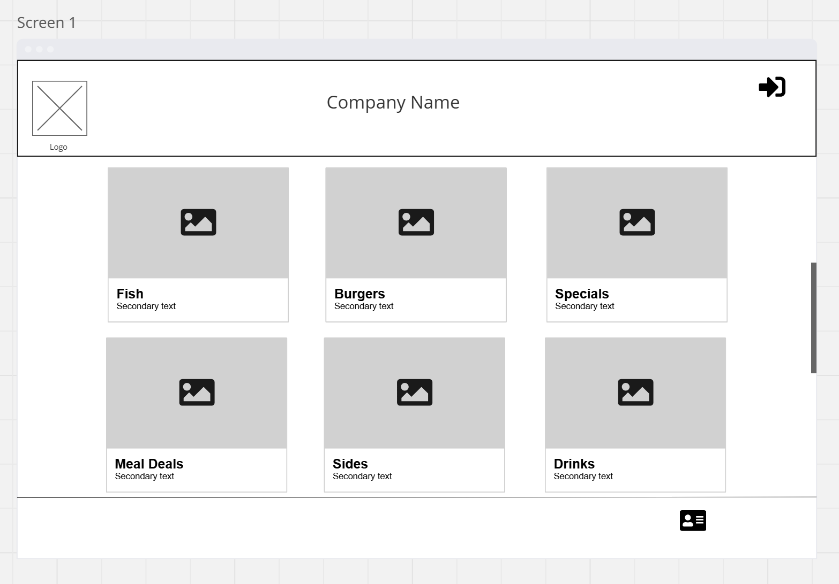

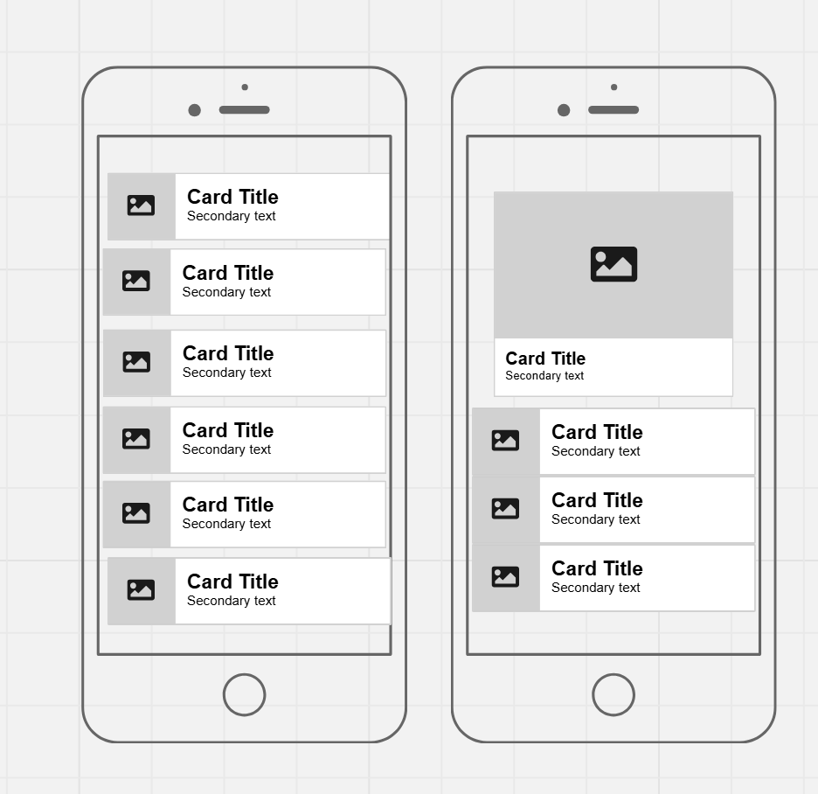
On selecting a category, the rest of the categories will collapse down in an accordion leaving only the title of each category as text in each. Mobile view shown here but the look will be the same on desktop
https://www.w3schools.com/howto/howto_js_accordion.asp

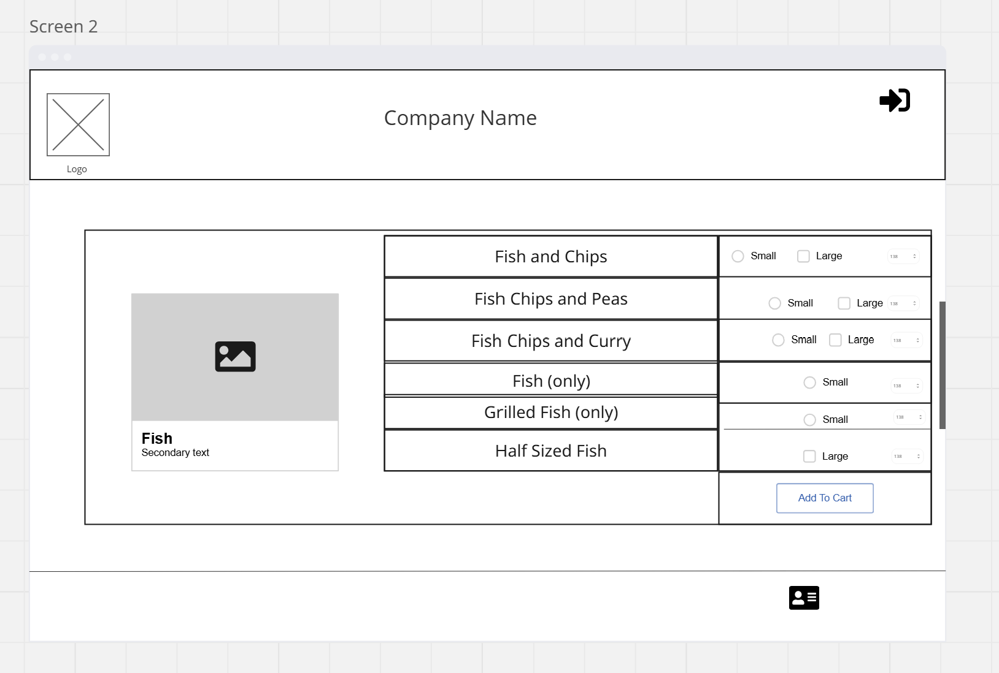
In each category when opened, the menu options will show up in a scrollable box inside the card. This stops the whole page length expanding too much allowing the user to easily select another category card without having to scroll up and down the page past the now expanded list of order items.

Categories Selected So Far

Fish and Chips
Chips
Sausage, Chicken and Burgers
Meal Deals and Kids
Sides and Extras
Drinks

Database work needed for this:
Each item (where applicable) will have a selection for Small or Large sizes. In most cases this will only be for the size of chips as menu items such as fish will be single size, and burgers will have separate options for single, double etc. on adding to cart a second option will be shown to select whether salt and vinegar should be added, and any options sauces like ketchup.
Items such as chicken nuggets/strips should have a separate option selecting dipping sauce options in place here. (options like sweet chilli, bbq etc will not be offered as sides for chips)

Categories:
  - Fish and chips

Fish and chips
Fish chips and peas
Fish bap
Half fish and chips
Fish
Fish Bites

  - Chips

Chips
Chips and curry
Chips and Gravy
Chips and Cheese
Chips Cheese and Gravy
Chips Cheese and Curry
Chips Cheese and Beans
Chip Bap

  - Sausage,Chicken, Burgers
Chicken Burger
Southern fried chicken burger
Double chicken burger
Double southern fried
Plain burger
Double burger
Cheese burger
Double cheeseburger
Hawaiian Burger
Chicken Nuggets
Chicken Strips
Chicken Breast
Sausage
Battered Sausage

  - Meal Deals and Kids

Meal deal box
Burger box
Chicken box
Kids meals –
Kids fish and chips
Kids chips cheese and gravy,
Kids chips and cheese
Kids sausage and chips
Kids nuggets and chips
Kids chips and curry
Various seasonal items, queenies?

  - Sides

Sauces – tomato, tartare, mayo, brown, sweet chilli, bbq, hot sauce, garlic mayo
Sides – mushy peas, gravy, peas, beans, curry sauce, cheese
Onion rings
Calamari
Bap
Battered mushrooms
Japeno poppers

  - Drinks
Coke, pepsi, Water, lemonade, fruit juices for kids meals (apple,orange?) dr pepper, fanta orange, lemon, fruit twist, lilt,

